Prototyping Assignment

By Ricardo Alvarez and Oscar Galindo

For this assignment we decided to implement features of our final project DSP system. We implemented three distinct controls, which are described below.

First a small look of our system, our implementation includes the options next to Apple’s logo which include “File”,” View”,” Run”, and “Help”.

1. Control and handling of text area.

For this element we added the functionality that in our main window every time the text in the text area changes then we check to see if there is a function that was declared. The way we do this is by running a regular expression on the text area content and we identify the name of functions. If the function is already declared we added to the list of tracked function on the sidebar’s combo box, else we do not add the function to the combo box’s options.

The tracked regular expression is ***r"def function \w+\(\)\:"***

For example,

Before input:

*Notice that Function 1 and Function 2 are placeholders

Input completed; combo box populated

Code

Dependency initialization:

*Notice extra dependencies are included as we were testing ideas

Listener construction:



Linking listener to tracked object:

In main:



*Notice we pass a function from an object that will listen when a change happens

In the visualization/main_window object:



Handling of input

Population of the listener dependencies:

*Notice combo box is stored as a dependency that can be referenced within the object of the listener

When text has changed:

1. File Explorer functionality when option “Open” is triggered.

For this implementation we added the functionality of being able to open or selecting a folder from any directory in the machine. Once the directory is selected, we are able to populate the tree widget or the navigation pane with the data found in that directory. For example,

System initiated; no directory selected

Open option triggered

Dialog appears and folder is selected

Once the option open is clicked the selected folder’s contents are shown in the file explorer

Code

Connecting the listener to the action of triggering the “Open” option.



Handling when a trigger occurs:

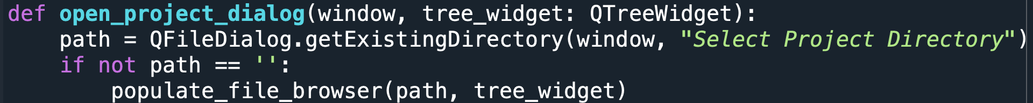

Populate with contents:

*Notice there is a helper function “add_children_to_folder” that aids on the discovery of new files.

*Notice this function populates the top tree, further items are populated by the helper function.

Helper function population at lower items of the tree

*Notice this function populates by discovering from the context of an item and adds children as needed and discovered.